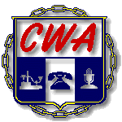

Local 3105
Gainesville, Florida
Grievance Escalation Form
Use when requesting Panel or Formal grievance

Grievance number: __________ Date of Informal: _____________

Date of occurrence: __________ 60 days on: _____________

Recessed: Yes ____ No ____

Director (3rd level): ___________________________________________

Manager (2nd level): ___________________________________________

Supervisor (1st level): ___________________________________________

Type of Grievance requested: ___ Formal (True Intent)

___ Panel (Contractual)

Present at Informal?

Yes No Scheduled Vacation 3months

___ ___ Grievant’s Name: _____________________ _____________________

___ ___ Steward’s Name: _____________________ _____________________

___ ___ Potential witness: _____________________ _____________________

CWA local 3105 Office: 352.377.3105
Please complete before calling up grievances to the Hall

